10, 11, 12 SSA

Brief outline of topics covered:

Ch. 10 The Unit Circle and Radian Measure

- Radian measure
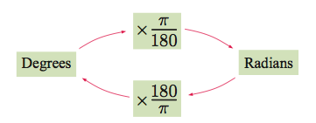
- Are length and Sector Area

In Radians: , 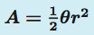

In Degrees: 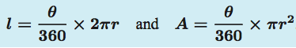

- Unit Circle and Soh, Cah, Toa
Note: Remember your special triangles!
- Areas of triangles

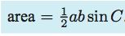

Ch. 11 Non-Right angled Trigonometry

- The Cosine Rule

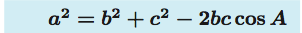
- The Sine Rule

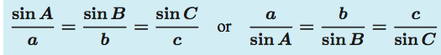

- Using the sine and cosine rule

Problem solving, and BEARINGS!

Ch. 12 Advanced Trigonometry

- Observing Period behavior

- The sine function

- Modelling using sine and cosine functions

- The cosine function

- The tangent function

- Trigonometric equations
  - Solve by hand, graphically, and approximating given a graph

- Using sine and cosine models

- Reciprocal trigonometric equations

- Trigonometric relationships

- Compound Angle formula

- Double angle formula

- Trigonometric equations in quadratic form

- Trigonometric series and products

Be familiar with all of the equations on the formula sheet:

Other items to have MEMORIZED:

- How to convert between degrees and radians
- Soh, cah, toa
- Special triangles for finding EXACT values

What else?!

