Angle Property Revision:



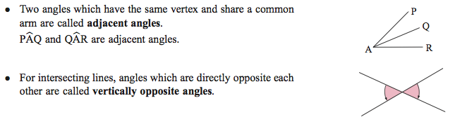

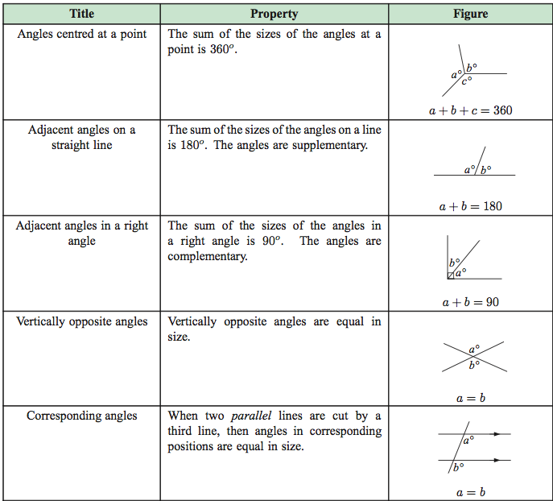

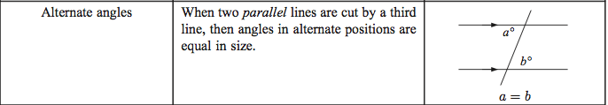

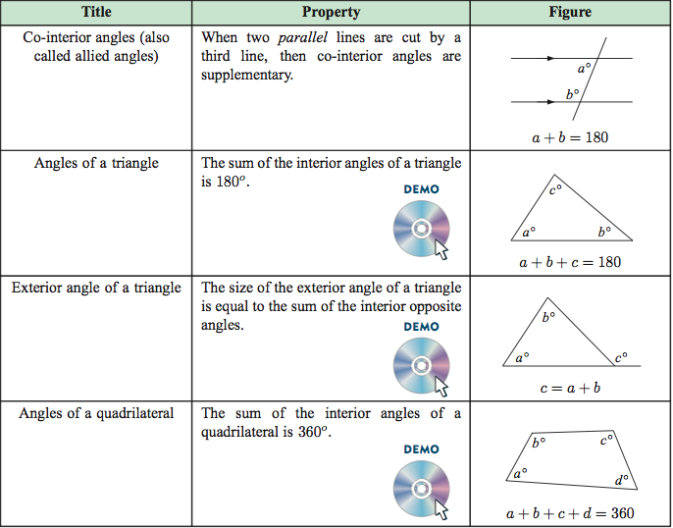

TRIANGLES:

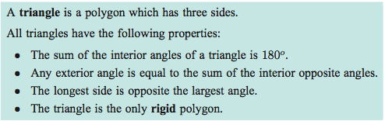

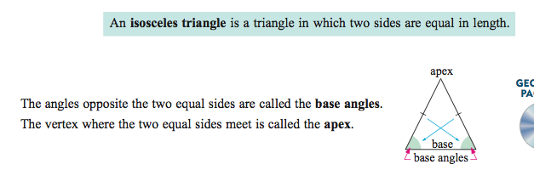

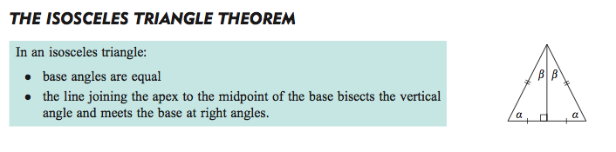

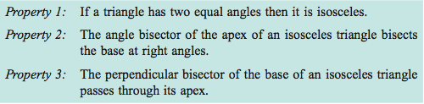

**Other shapes:**



