Chapter 21/22AD Assessment

(Note: Chapter 22 section B and C will be EXCLUDED)

A quick review guide for you.

- Anti-differentiation

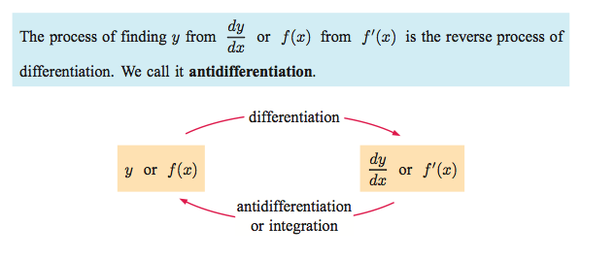

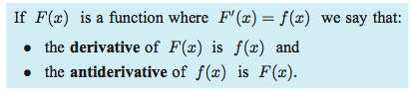

- The Fundamental Theorem of Calculus

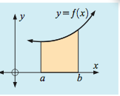

A few properties of definite integrals
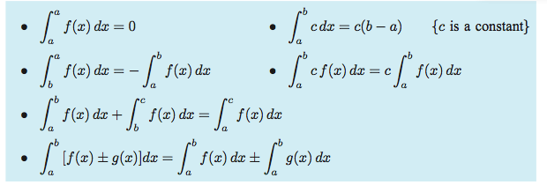

- Indefinite Integration
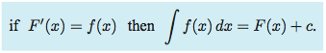

A list of DERIVATIVE rules
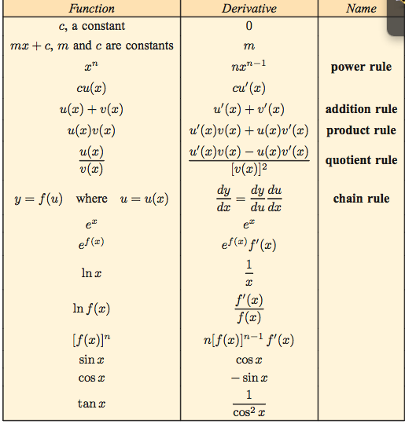
Helpful hint:
sin(x)
cos(x)
-sin(x)
-cos(x)
A list of ANTIDERIVATIVE (or integration) rules
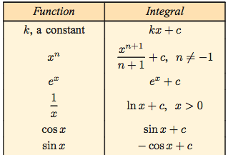

Alternatively, we could write:

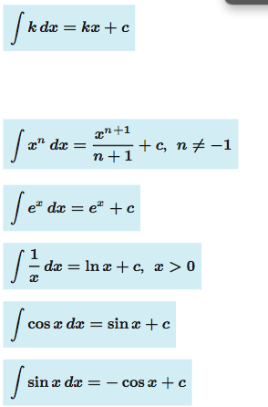

Remember that it is often useful to ALGEBRAICALLY simplify or manipulate a function FIRST, and then integrate:

For example:
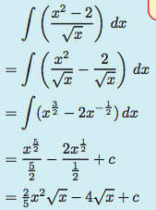

- Integrating f(ax+b)

For composition functions involving a LINEAR function, you must remember to multiply by 1/a to cancel the chain rule!

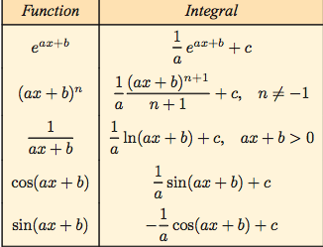

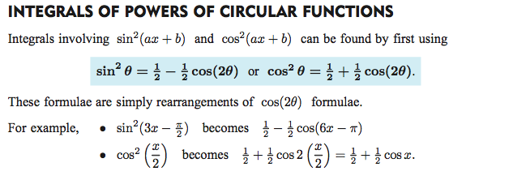

- Definite Integrals

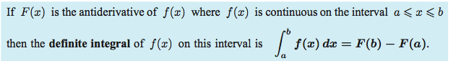
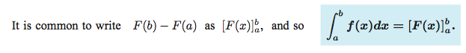

YOU MUST KNOW HOW TO USE YOUR CALCULATOR TO EVALUATE!
(see next page)

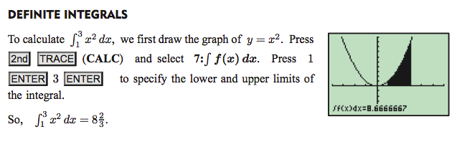

You can also do this manually on your calculator by doing the following (old OS)

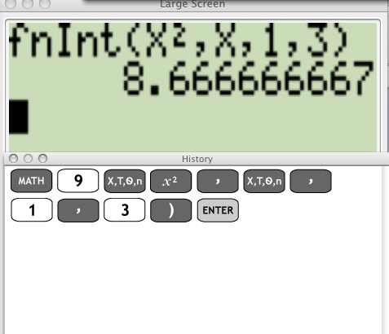

On the NEW OS, the display is much nicer (and mathematically correct!)
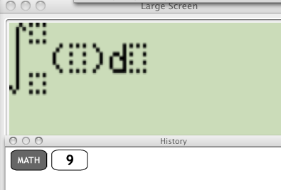Then simply plug in the upper and lower limits, function, and variable with which you will be anti differentiating with respect to.

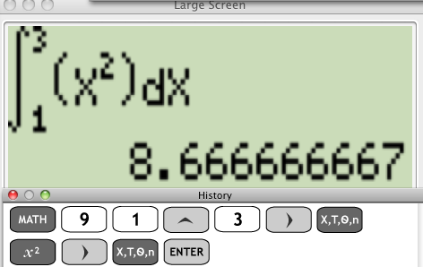

22.A Area underneath a curve

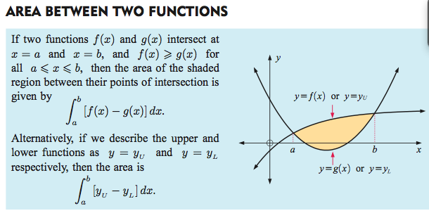

22D. VOLUMES OF REVOLUTION

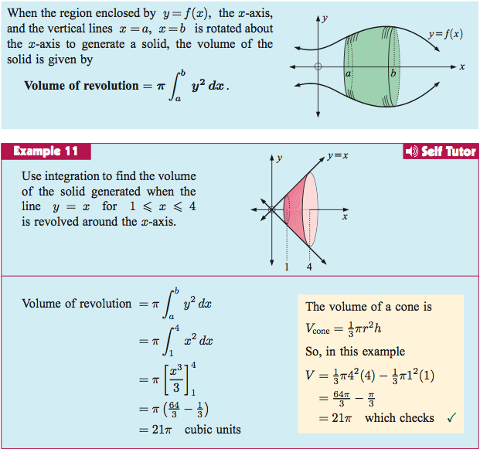

IF YOU WANT TO ROTATE THE AREA BOUND BETWEEN TWO CURVES……THINK OF IT IN SECTIONS!
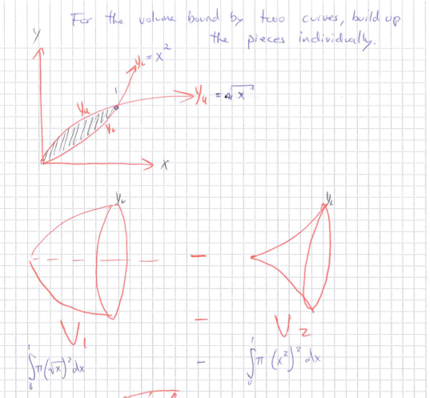
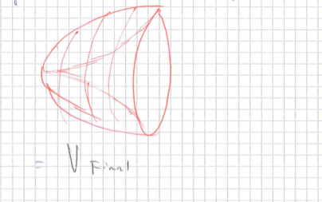

You should also be aware of the formulas that are given on the IB formula sheet!

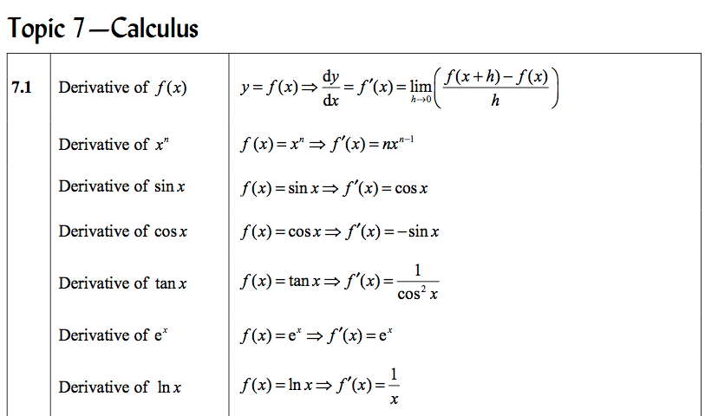

(continued next page)

