**Name:________________________________**

**IGCSE 10 III**

**Transforming functions**

**Extension Problems**

**1.** The following diagram shows part of the graph of *f* (*x*) = 5 − *x*2 with vertex V (0, 5).

Its image *y* = *g* (*x*) after a translation with vector  has vertex T (3, 6).

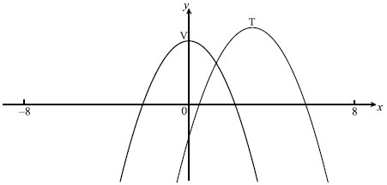

(a) Write down the value of

(i) *h*;

(ii) *k*.

(2)

(b) Write down an expression for *g* (*x*).

(2)

(c) On the same diagram, sketch the graph of *y* = *g* (−*x*).

(2)

..............................................................................................................................................

..............................................................................................................................................

..............................................................................................................................................

..............................................................................................................................................

..............................................................................................................................................

..............................................................................................................................................

..............................................................................................................................................

..............................................................................................................................................

..............................................................................................................................................

..............................................................................................................................................

(Total 6 marks)

**2.** The graph of a function *f* is shown in the diagram below. The point A (–1, 1) is on the graph, and *y* = −1 is a horizontal asymptote.

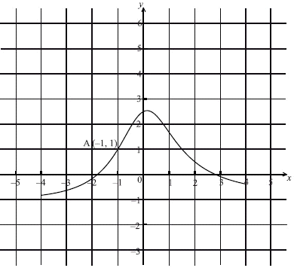

(a) Let *g* (*x*) = *f* (*x* −1) + 2. On the diagram, sketch the graph of *g*.

(b) Write down the equation of the horizontal asymptote of *g*.

(c) Let A′ be the point on the graph of *g* corresponding to point A. Write down the coordinates of A′.

..............................................................................................................................................

..............................................................................................................................................

..............................................................................................................................................

..............................................................................................................................................

..............................................................................................................................................

..............................................................................................................................................

..............................................................................................................................................

..............................................................................................................................................

..............................................................................................................................................

(Total 6 marks)

**3.** The following diagram shows part of the graph of *f* (*x*).

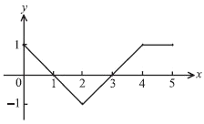

Consider the five graphs in the diagrams labelled A, B, C, D, E below.

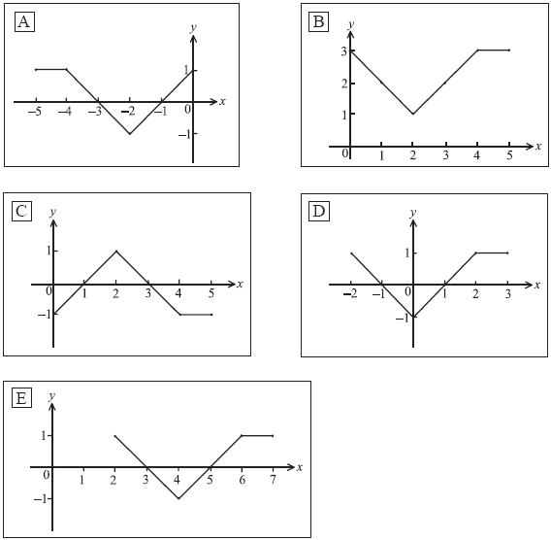

(a) Which diagram is the graph of *f* (*x* + 2) ?

(b) Which diagram is the graph of – *f* (*x*) ?

(c) Which diagram is the graph of *f* (–*x*)

..............................................................................................................................................

..............................................................................................................................................

..............................................................................................................................................

(Total 6 marks)

**4.** The sketch shows part of the graph of *y* = *f* (*x*) which passes through the points A(–1, 3), B(0, 2), C(l, 0), D(2, 1) and E(3, 5).



A second function is defined by *g* (*x*) = 2*f* (*x* – 1).

(a) Calculate *g* (0), *g* (1), *g* (2) and *g* (3).

(b) On the same axes, sketch the graph of the function *g* (*x*).

|  |  |
| --- | --- |
| *Working:* |  |
|  | *Answers*:  (a) ..................................................................  .................................................................. |

(Total 6 marks)

**5.** The diagram shows parts of the graphs of *y* = *x*2 and *y* = 5 – 3(*x* – 4)2.



The graph of *y = x*2 may be transformed into the graph of *y* = 5 – 3(*x* – 4)2 by these transformations.

A reflection in the line *y* = 0 **followed by**a vertical stretch with scale factor *k* **followed by**a horizontal translation of *p* units **followed by**a vertical translation of *q* units.

Write down the value of

(a) *k*;

(b) *p*;

(c) *q.*

|  |  |
| --- | --- |
| *Working:* |  |
|  | *Answers*:  (a) ..................................................................  (b) ..................................................................  (c) .................................................................. |

(Total 4 marks)

EXTRA CREDIT

Given the graph of *y=* *f(x*) below, sketch *y=-0.5f*(x+2) -3

