Finding areas under the curve.

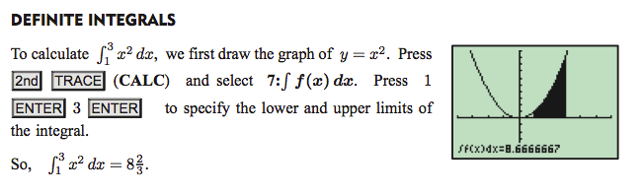

You can also do this manually on your calculator by doing the following (old OS)

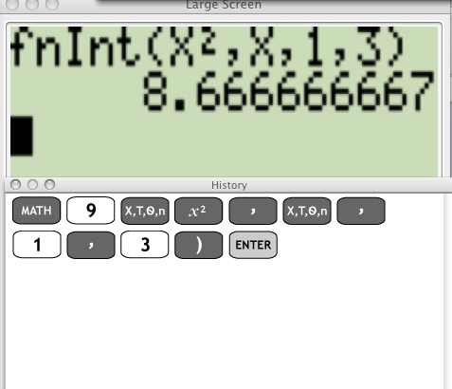

On the NEW OS, the display is much nicer (and mathematically correct!)
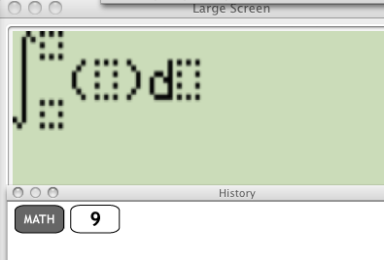Then simply plug in the upper and lower limits, function, and variable with which you will be anti differentiating with respect to.

