Mathematics SL review material

Topic 1—Algebra 2

Topic 2—Functions and equations 5

Topic 3—Circular functions and trigonometry 12

Topic 4—Matrices 18

Topic 5—Vectors 20

Topic 6—Statistics and probability 23

Topic 7—Calculus 31

NC = non calculator question

## Topic 1—Algebra

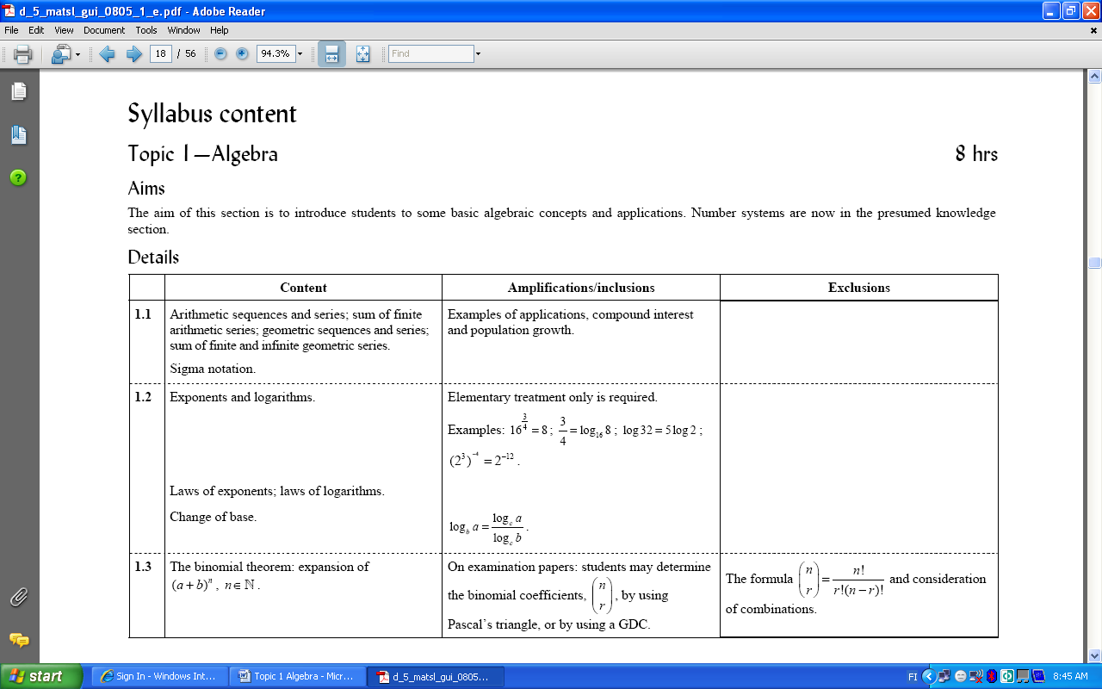

1. In an arithmetic sequence, the first term is 8 and the 78th term is 1009. Find the common difference *d*.
2. Find the sum of the arithmetic series 100 + 97 + 94 + ... + (– 1967).
3. Find the general term of the geometric sequence which has: and 
4. Find the sum of the geometric series 3 + (–6) + 12 + (–24) + ... + 49152.
5. Find the sum of the infinite geometric series
6. Calculate
7.  b) 
8. 50 000 € is invested for 20 years. The rate of interest is fixed at 2.75% per annum. Interest is compounded annually. Calculate, giving your answer to the nearest euro, the total value of the investment at the end of the 20 years.
9. A town has a population of 4500 people. If the population of the town is growing by 3% p.a., how long will it take for the town to double in size?

______________________

**Answers:**

1. 13
2. – 644 115
3. 
4. 32 769
5. 3
6. a) 63 b) 121
7. 86 021 €
8. 24 years



1. (NC) Simplify
2. 
3. 
4. 
5. (NC) Simplify
6. 
7. 
8. 
9. (NC) If  and  find the expression in *x* and *y* for the following
10. 
11. 
12. 
13. 
14. Calculate to 3 s.f.
15. 
16. 

________________________

**Answers:**

1. a)  b)  c) 9
2. a)  b)  c) 
3. a) 3*x* b) *x* + *y* c) *x* – *y* d) 2*x* - 3*y*
4. a) 3.46 b) 2.88

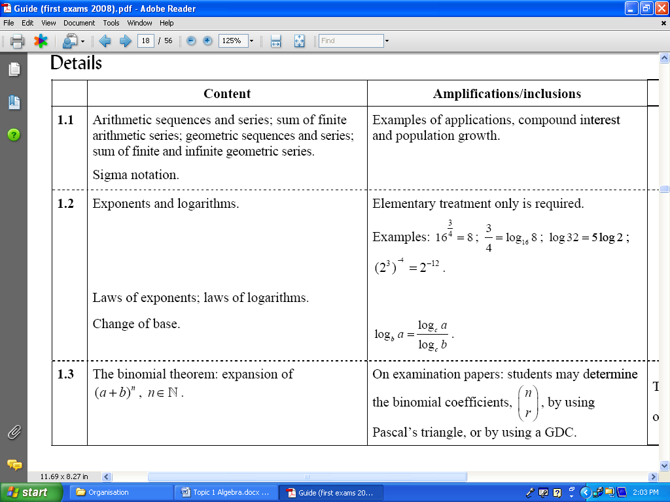

1. Use your calculator to find the value of the following
2. 
3. 
4. Expand 
5. Find the coefficient of  in the expansion of 
6. Find the constant term in the expansion of 

_______________________

**Answers:**

1. a) 15 b) 21
2. 
3. 153090
4. -20

## Topic 2—Functions and equations

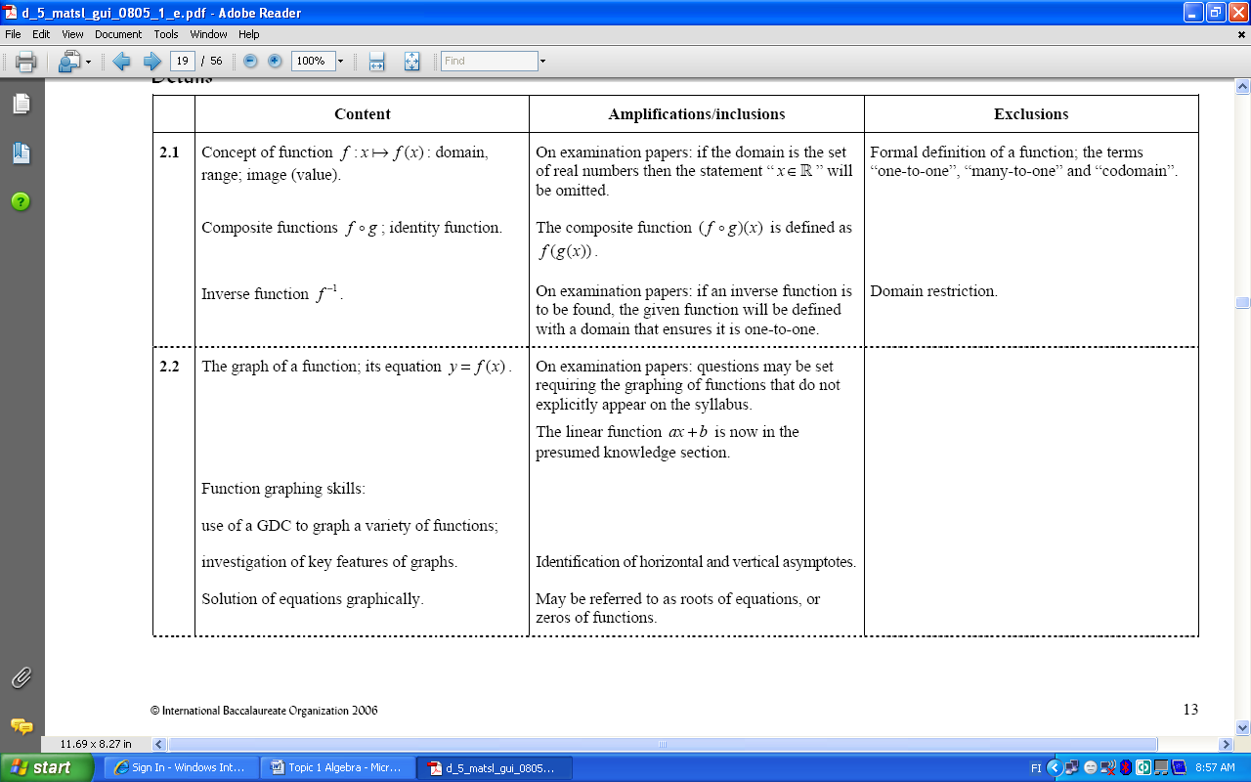

1. (NC) State the domain and range of the following functions:
2. 
3. 
4. 
5. 
6. (NC)  and , find
7. 
8. 
9. 
10. 
11. (NC) a) Find the inverse of 

b) Find . What do you notice?

________________________

**Answers:**

1. a) ,  b) ,  c) ,  d) , 
2. a) -5 b) *x* = 0 or *x* = -1 c)  d) 
3. a)  b) the answer is an identity function *f*(*x*) = *x*



1. The function is defined by  for  .
2. Sketch the graph of *f*(*x*).
3. Write down the equation of each vertical asymptote.
4. Solve the equation using GDC .

________________________

**Answers:**

1. a) b) *x* = 2, *x* = -2
2. *x* = 0.647

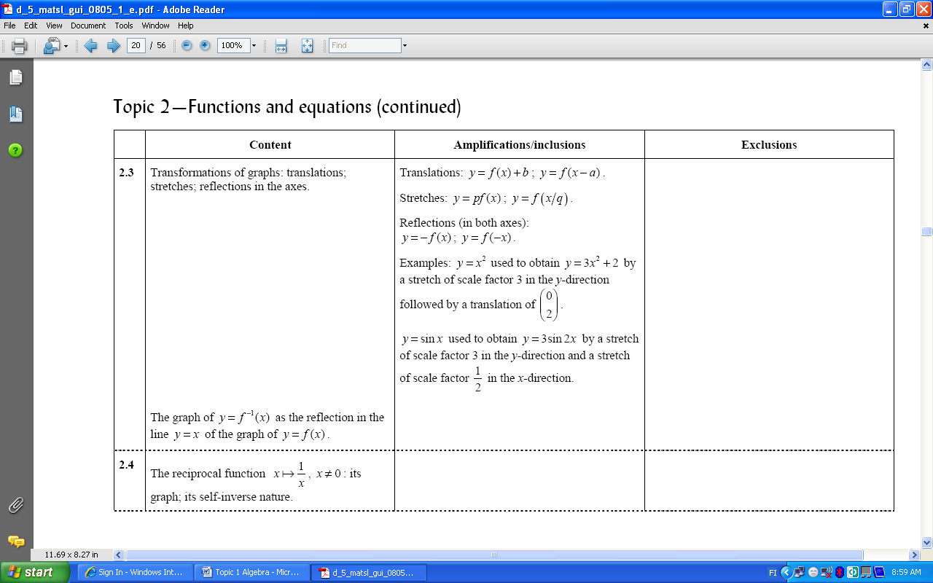



1. (NC) Given the function 

* translate it horizontally 2 units to the right
* reflect in the *x*-axis
* translate it vertically 3 units up

Write down the equation of the transformed graph.

1. (NC) If under goes a translation of write down the equation of the translated graph. What are the asymptotes of the translated graph?
2. (NC) Sketch the graph of . What are the asymptotes?

________________________

**Answers:**

1. 
2.   
3.  

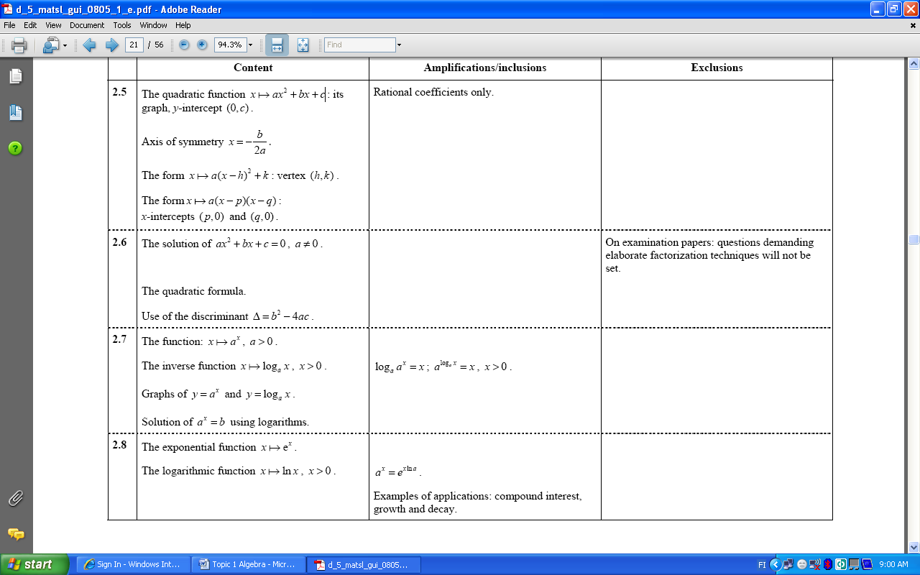

1. (NC) , find
2. coordinates of the *y*-intercept
3. the axis of symmetry
4. coordinates of the vertex
5. (NC) The graph below has an equation in the form , find *a*, *h* and *k*.



1. (NC) Write  in the form . What are the coordinates of the vertex?



1. (NC) The graph has an equation in the form , find *a*, *p* and *q*.

________________________

**Answers:**

1. a) (0,-4) b) *x* = -2 c) (-2,-12)
2. *a* = 2, *h* = 2, *k* = -3
3. 
4. *a* = -1/2 *p* = -1 and *q* = 4



1. Solve the following equations using quadratic formula
2. 
3. 
4. (NC) Solve  using factorization.
5. (NC) Find the value for *k* so that equation
6.  has exactly one real root.
7. has two real solutions.
8. has no real roots.

________________________

**Answers:**

1. a) -2.73 or 0.732 b) 1.29 or -1.09
2. 5 or -2
3. a) *k* = 9 b) *k* < 4 c) 



1. (NC) Evaluate
2. 
3. 
4. 
5. (NC) Find the inverses of the following functions
6. 
7. 
8. 
9. Sketch the graphs of and in the same set of axis. What do you notice?
10. Solve to 3 s.f.
11. 
12. 
13. 

________________________

**Answers:**

1. a) 2 b) -3 c) 4
2. a)  b)  c) 
3. The graph of *f*(*x*) is the reflection in the line *y* = *x* of the graph g(*x*). Functions are inverse functions.
4. a) 0.477 b) 0.567 c) 15.8



1. Solve to 3 s.f.
2. 
3. 
4. (NC )Find the inverse of the following functions
5. 
6. 
7. Find the value of the given investment after the indicated years at the given rate
8. $6 000 after 3 years at 7% p.a.
9. $10 000 after 10 years at 5% p.a.
10. A person has $15 000 to invest at 5% p.a., how long does it take for his investment to exceed $22 000?
11. The number of bacteria present in a culture at *t* (hours) is given by the equation 
12. Find the number of bacteria present initially.
13. Find the number of bacteria present after 8 hours.
14. How long does it take the number of bacteria to double?
15. A radioactive substance is decaying so that its weight *W*(g) after *t* days is given by the equation .
16. What is the weight of the substance after 15 days?
17. How long does it take to get to 25% of its original weight?

________________________

**Answers:**

1. a) 1.61 b) 2980
2. a)  b) 
3. a) $7350 b) $16289
4. 8 years
5. a) 400 b) 9813 c) 1.73 hrs (1 hr 44 min)
6. a) 4.98 g b) 7 days

## Topic 3—Circular functions and trigonometry

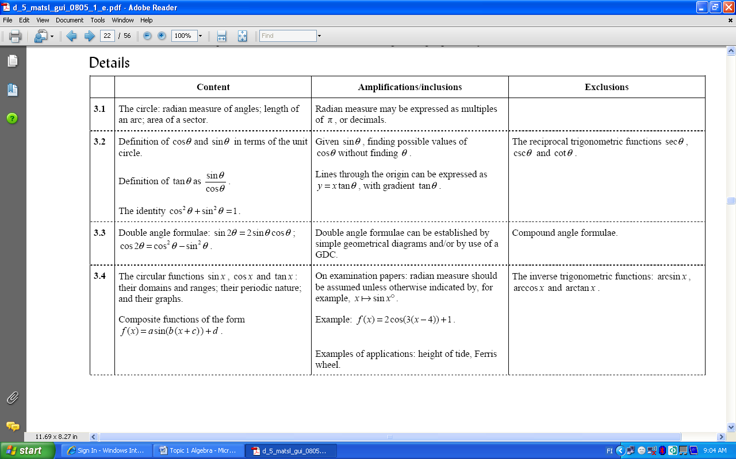

1. Convert into radians
2. 
3. 
4. 
5. Convert into degrees
6. 
7. 
8. 2.13
9. Calculate the perimeter of the sector, if radius is 2.7 cm and angle is.
10. Calculate the area of the sector if radius is 3.1 cm and angle is 3.8 rad.

_______________________

**Answers:**

1. a)  b)  c) 
2. a)  b)  c) 
3. 11.0 cm
4. 18.3 cm2



1. (NC) Find the exact values of the following using the unit circle.
2. 
3. 
4. 
5. (NC) and. Find exact value of.
6. (NC) Make  the subject .
7. (NC) If and  find .
8. (NC) Find the equation of the straight line which makes an angle of 60 degrees with the *x*-axis and cuts the y-axis at (0,-2).

_______________________

**Answers:**

1. a) -1 b)  c) 
2. 
3. 
4. 
5. 



1. (NC) Factorize *.*
2. (NC) Write  in the form .

_______________________

**Answers:**

1. 
2. 



1. (NC) State the domain, range and period of the following functions
2. 
3. 
4. 
5. (NC), state the
6. amplitude
7. period
8. vertical translation
9. horizontal translation
10. The model for the height of tide (in meters above mean sea level) is

 (*t* is number of hours after midnight)

1. What was the height at 1 pm?
2. When was the high tide and what was was the maximum height?
3. The model for the height (in meters above the ground) of a light on a Ferris wheel is  (*t* is time in minutes)
4. Where is the light at time *t* = 0 min?
5. How long does the wheel take to complete one revolution?
6. At what time was the light at its highest in the first revolution of the wheel?

_______________________

**Answers:**

1. a)  b)  c) 
2. a) 2 b)  c) 1 step up d) 4 steps to the right
3. a) 2 m above the mean b) 4 m above the mean
4. a) 22.0 m b) 3 min c) 2 ¼ min

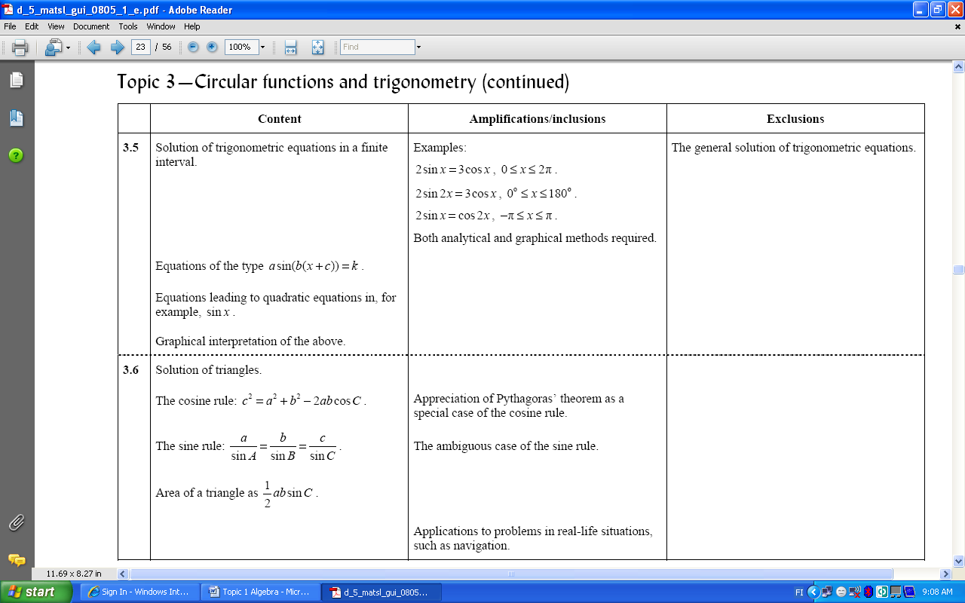

1. Solve
2. 
3. 
4. 
5. (NC) Solve 
6. (NC) Solve
7. 
8. 

_______________________

**Answers:**

1. a) 0.983 rad, 4.12 rad b) 90 degrees, 48.6 degrees, 131.4 degrees c) 0.375 rad, 2.77 rad
2. 
3. a)  b) 



1. A triangle has sides 5 cm, 7 cm and 8 cm. Find the size of the biggest angle in degrees.
2. Find the two values for the angle A in the triangle ABC where angle C = 35 degrees, AB = 9 cm and BC = 14 cm.
3. Find the area of the triangle with sides AB = 10 cm, AC = 9 cm and the angle BAC = 54 degrees.
4. Three towns are positioned so that A is 41 km from B and C is 35 km from B. If the angle ABC = 46 degrees, how far apart are A and C?

_______________________

**Answers:**

1. 81.8 degrees
2. 63.2 or 116.8 degrees
3. 36.4 cm2
4. 30.2 km

## Topic 4—Matrices

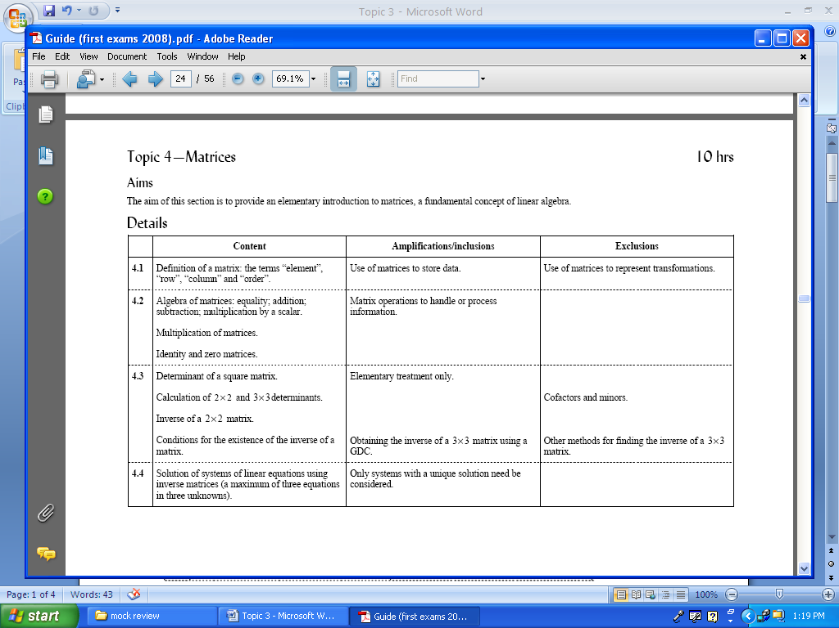

1. (NC) a) What is the order of the following matrices

i) 

ii) 

b) Calculate AB and BA.

1. (NC) Solve the equations, where A, B and X are matrices.
2. 2*X* = *A*
3. *AX* = *B*
4. *XA* = *B*

_______________________

**Answers:**

1. a) i) 2x3 ii) 3x1 b)  , BA is not defined
2. a)  b)  c) 



1. (NC) Calculate the determinant
2.  b) 
3. (NC) Find the inverse of 
4. Find the inverse of 
5. (NC)  state *k* when A-1 exists.
6. Solve using matrices
7.  b) 

_______________________

**Answers:**

1. a) -2 b) 26
2. 
3. 
4. 
5. a) *x* = 8, *y* = 1 b) *x* = 1, *y* = -2, *z* = -2

## Topic 5—Vectors

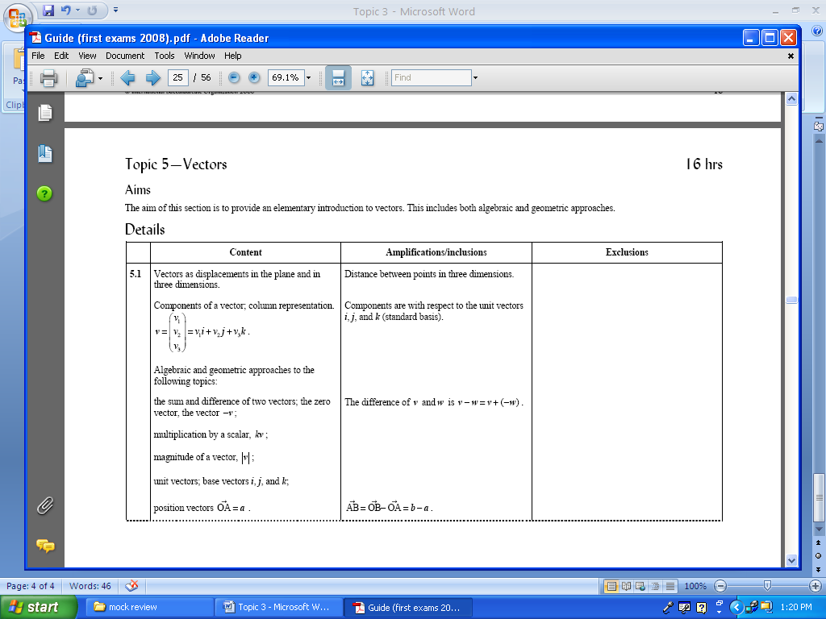

1. (NC) A = (2,3) and B = (5,7). Find
2. 
3. magnitude of 
4. Calculate the distance between the points (2, 0, 3) and (1, 6, 4).
5. (NC) Find the unit vector in the direction of 

_______________________

**Answers:**

1. a)  b) 
2. 6.16
3. 

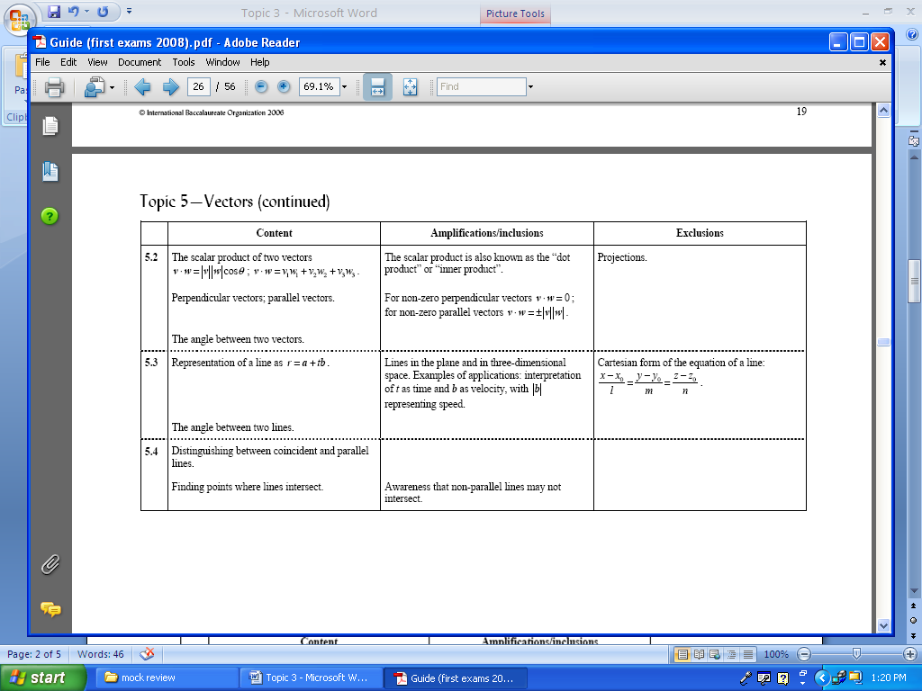

1. (NC) Consider the vectors  and . Calculate the scalar product.
2. (NC) Find *k* so that vectors  and  are
3. parallel
4. perpendicular
5. Calculate the angle between the vectors  and .

_______________________

**Answers:**

1. -13
2. a) 9 b) -4
3. 112 degrees



1. (NC) Write down the vector equation of the line parallel to the line  and passing through the point (3,7,8).
2. Find the angle between the two lines with equations and 
3. An object is moving with constant velocity km/h along a straight line. At the time *t* = 0 it is at the point (-1,5).
4. Write down the vector equation representing the position of the object.
5. Find the speed of the object.
6. Find the point of intersection of the following lines and 

_______________________

**Answers:**

1. 
2. 78.7 degrees
3. a)  b) 3.61 km/h
4. (-1,4,5)

## Topic 6—Statistics and probability

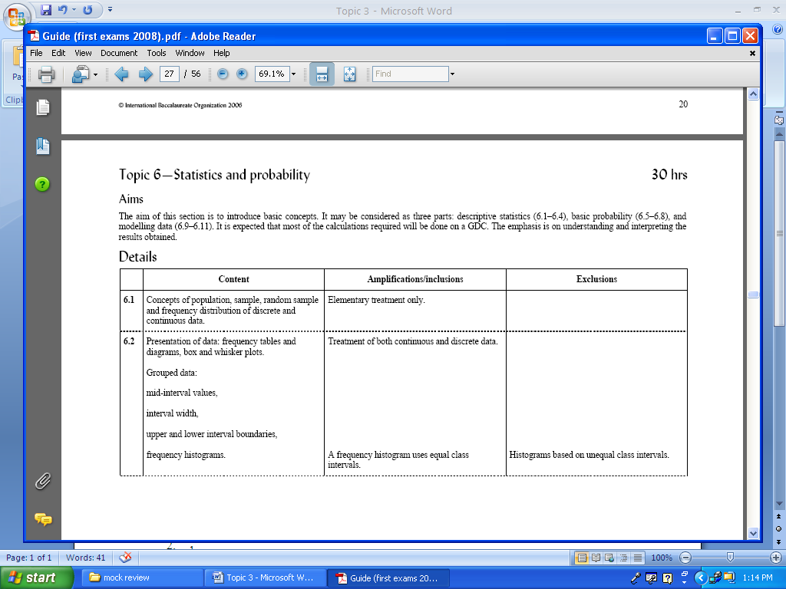

1. What is the difference between discrete and continuous data?
2. (NC) Using the box and whisker plot given, find
3. 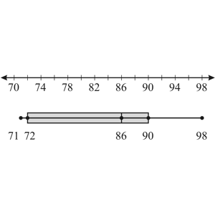the median
4. the lower quartile
5. the upper quartile
6. the range.

______________________

**Answers:**

1. Discrete data can be counted and is usually recorded as whole numbers with a limited number of values. Continuous data can be measured.
2. a) 86 b) 72 c) 90 d) 27

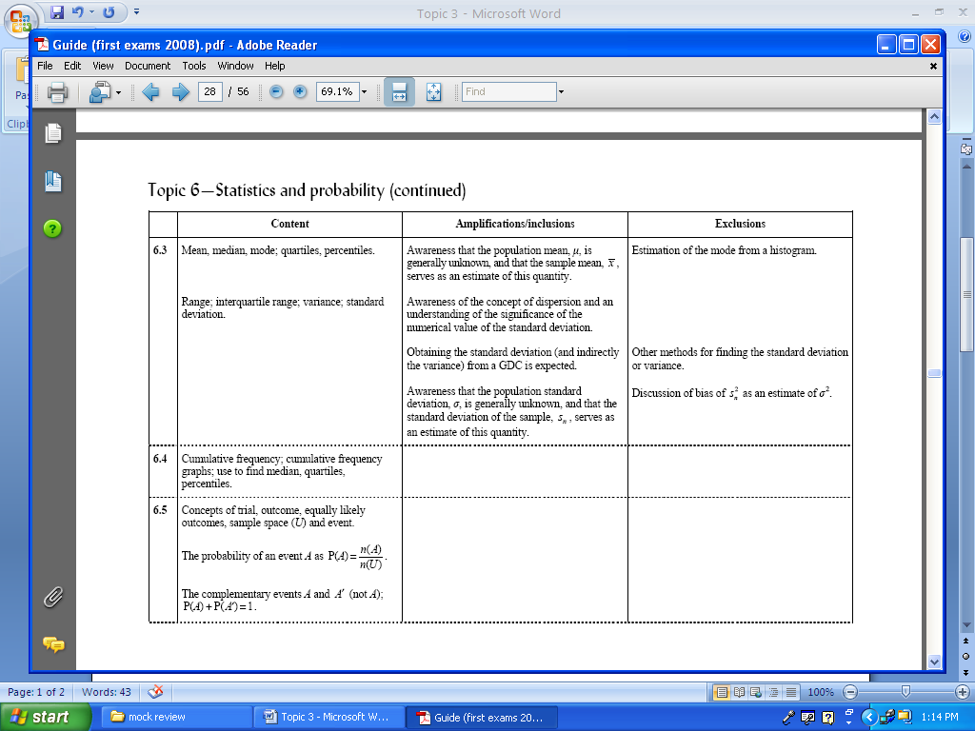

1. (NC) Find the mean, median and mode of the following data
2. 2, 5, 2
3. 2, 1, 8, 1
4. (NC) Find the
5. range
6. lower quartile
7. upper quartile
8. interquartile range (IQR) of the following
9. 1, 3, 3, 5, 5, 4, 4, 4, 2, 2, 2, 2
10. 1, 2, 3, 3, 4, 4
11. Calculate the standard deviation and variance
12. 167, 171, 173, 176, 180

|  |  |
| --- | --- |
| score | frequency |
| 1 | 3 |
| 2 | 1 |
| 3 | 8 |
| 4 | 5 |

______________________

**Answers:**

1. a) mean: 3, median: 2, mode: 2 b) mean: 3, median: 1.5, mode: 2
2. a) i) 4 ii) 2 iii) 4 iv) 2 b) i) 3 ii) 1 iii) 4 iv) 3
3. a) var: 19.4 sd: 4.41 b) var: 1.04 sd: 1.02



1. Use the cumulative frequency graph to estimate the
2. median
3. upper quartile
4. lover quartile
5. 90th percentile

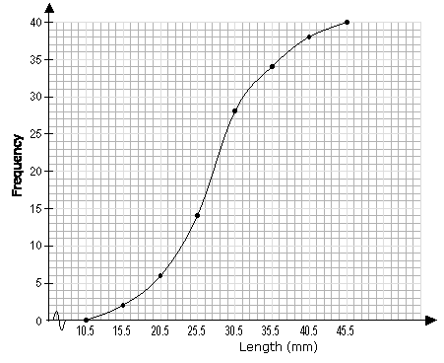

______________________

**Answers:**

1. a) 27.5 b) 31.5 c) 23.5 d) 36.5



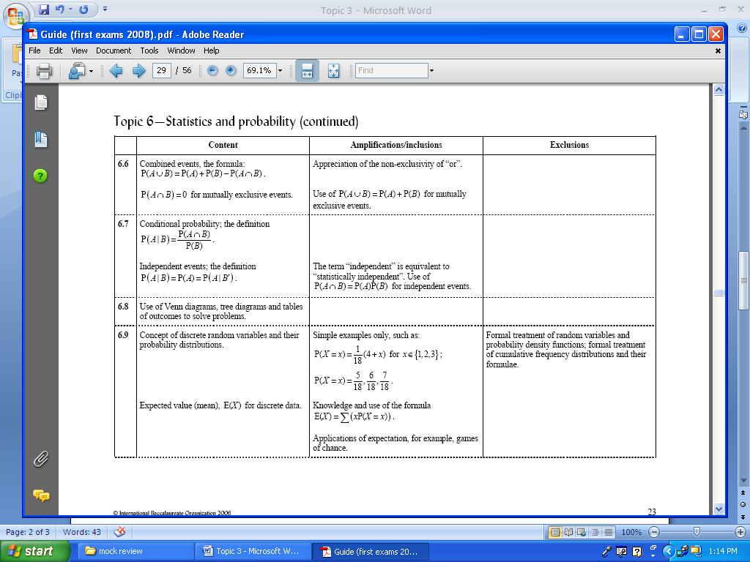

1. (NC) List the sample space for
2. rolling a die
3. tossing two coins
4. (NC) P(A) = 0.5 , P(B) = 0.3 and. Find 
5. (NC) From a bag containing 5 white balls, 2 black balls, and 11 red balls, 1 ball is drawn. What is the probability that it is either black or red?

______________________

**Answers:**

1. a) {1,2,3,4,5,6} b) {HT, TH, TT, HH}
2. 0.2
3. 13/18



1. Two machined are operating independently. Machine A operates for 70 % of the time and machine B operated for 80 % of the time. Draw a tree diagram and
2. Calculate the probability that both machines are working
3. Calculate the probability that only one machine is working
4. Given that only one machine is working, what is the probability that it is machine B?
5. 70 % of the people shop at market A and 60 % at market B. 50 % shop at both markets. Represent this on a Venn diagram and
6. Calculate probability that a person doesn’t shop at either market
7. Find and  .
8. A pair of dice is rolled.  What is the probability that the sum of the numbers rolled is
9. either 7 or 11?
10. either an even number or a multiple of 3?
11. A jar contains 3 red, 5 green, 2 blue and 6 orange marbles. A marble is chosen at random from the jar. After replacing it, a second marble is chosen. What is the probability of choosing a green and an orange marble?
12. A bag of sweets contains 10 red and 12 yellow sweets. Two sweets are taken (without replacement) what is the probability that
13. both are yellow
14. only one is yellow
15. at least one is yellow?

______________________

**Answers:**

1. a) 0.56 b) 0.38 c) 0.421
2. a) 0.2 b) 0.833 and 0.714
3. a) 2/9 b) 2/3
4. 15/128
5. a) 0.286 b) 0.519 c) 0.805



1. a) Show that is a probability distribution function.

b) Calculate the expected value.

1. A coin is tossed once. It a tail appears you win 3 euros and if head appears you lose 2 euros. How much would you expect to win when playing the game four times?

______________________

**Answers:**

1. a) - b) 2.11
2. 2 euros

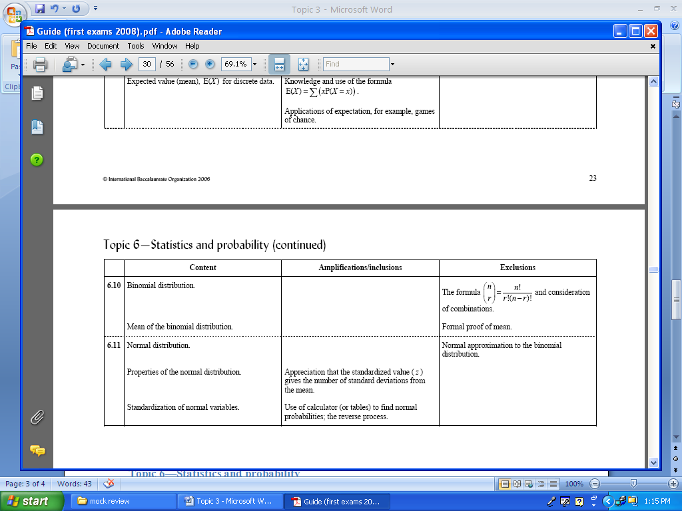

1. (NC) Which ones are binomial random variables?
2. 2 % of bolts are defective. A random sample of 50 bolts is taken with replacement. The variable is the number of faulty bolts.
3. A die is tossed 60 times. The variable is the number of sixes.
4. A bag contains 3 brown and 5 white sweets. I eat 2 sweets. The variable is the number of white sweets eaten.
5. There are 30 true-false questions in the test. Student guesses all the answers. The variable is the number of correct answers.
6. If . Calculate
7. 
8. 
9. 
10. the mean.
11. A student is taking a multiple-choice exam in which each question has four choices. If there are five multiple-choice questions on the exam, what is the probability that student will get
12. five questions correct?
13. at least four questions correct?

______________________

**Answers:**

1. a, b and d
2. a) 0.201 b) 0.879 c) 0.0328 d) 2
3. a) 0.0098 b) 0.0156



1. If Z is a standard normal variable, find
2. 
3. 
4. 
5. If Z is a standard normal variable, find *k*
6. 
7. 
8. X is a random variable and distributed normally with mean 50 and standard deviation 4 find
9. 
10. 
11. 
12. The height of the students are normally distributed with mean 171 cm and standard deviation 9 cm. Find the probability that a randomly selected student is
13. At least 173 cm tall
14. Between 165 cm and 175 cm
15. 85% of the students will pass the exam. Exam results are expected to be normally distributed with the mean 53 and standard deviation 9. Find the lowest score needed to pass the exam.

______________________

**Answers:**

1. a) 0.885 b) 0.264 c) 0.299
2. a) 0.806 b) 1.92
3. a) 0.999 b) 0.994 c) 0.988
4. a) 0.412 b) 0.419
5. 62

## Topic 7—Calculus

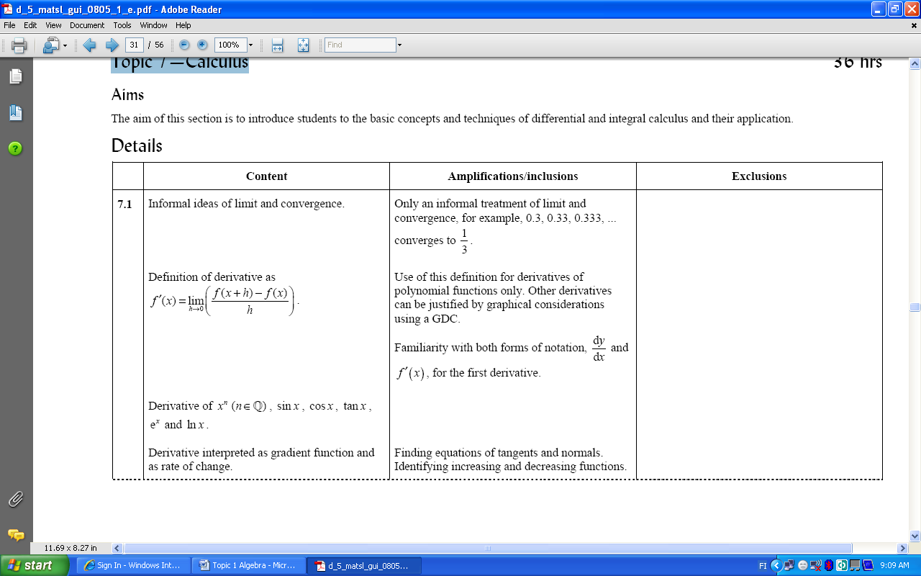

1. (NC) Find the derivative of  using the first principles method (=definition of the derivative).
2. (NC) Find the gradient of the tangent to the curve at.
3. (NC) Find the equation of the tangent to the curve at the point x = 3.
4. (NC) Find the gradient of the normal to the curve  at.
5. (NC) Find the equation of the normal to the curve at the point *x* = 1.
6. (NC) Find the range of values of *x* where the function
7. is increasing
8. is decreasing.

______________________

**Answers:**

1. 
2. -1
3. 
4. -1
5. 
6. a)   b) 

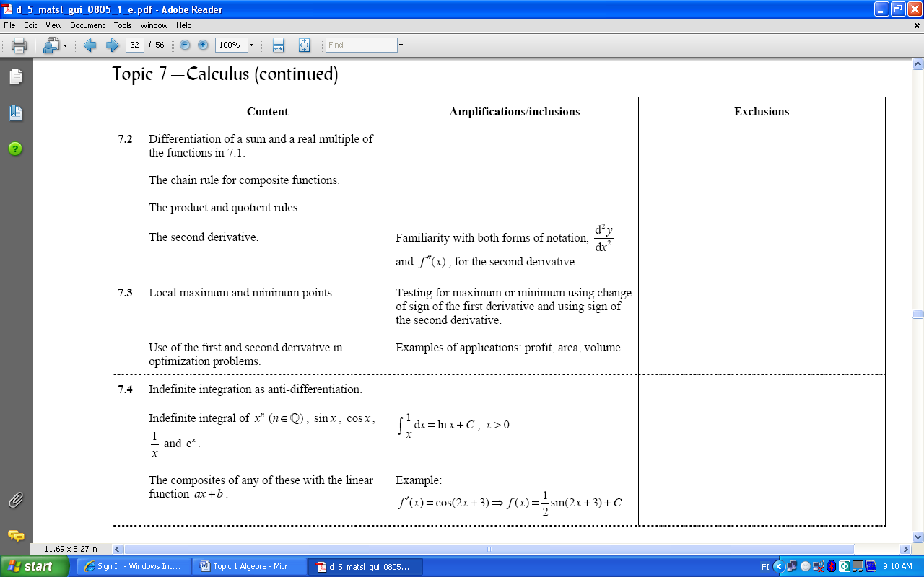

1. (NC) Differentiate
2.  b) 
3. (NC) Find the derivative (using the chain rule)
4. 
5. 
6. 
7. 
8. 
9. 
10. 
11. (NC) Find the gradient function
12.  b) 
13. (NC) Find  if 

_____________________

**Answers:**

1. a)  b) 
2. a)  b)  c)  d)  e) f)  g) 
3. a)  b) 
4. 



1. (NC) Find the local maximum and minimum value of
2. 
3. 
4. (NC) A manufacturer produces toys at a cost of  cents each. Each toy is sold for 45 cents.
5. Write down the expression for the profit made in making and selling *x* toys.
6. Find the number of toys that should be made to maximize the profit.
7. (NC) A rectangular field is formed using 1200 m of fencing. Find the dimensions of the field if the area is a maximum.
8. A container is made by cutting out the squares from the corners of a 12 cm by 12 cm square sheet of metal and folding the remaining sheet to form the container. What size squares must be cut out in order to maximize the volume of the container? What is the volume in this case?

______________________

**Answers:**

1. a) max , min b) min , no max
2. a)  b) 5 toys
3. both sides are 300 m
4. 2 cm by 2 cm, 128 cm3



1. (NC) Integrate
2. 
3. 
4. 
5. 
6. 
7. (NC) Integrate
8. 
9. 
10. 
11. 
12. 

______________________

**Answers:**

1. a)  b)  c)  d)  e) 
2. a)  b)  c)  d)  e) 

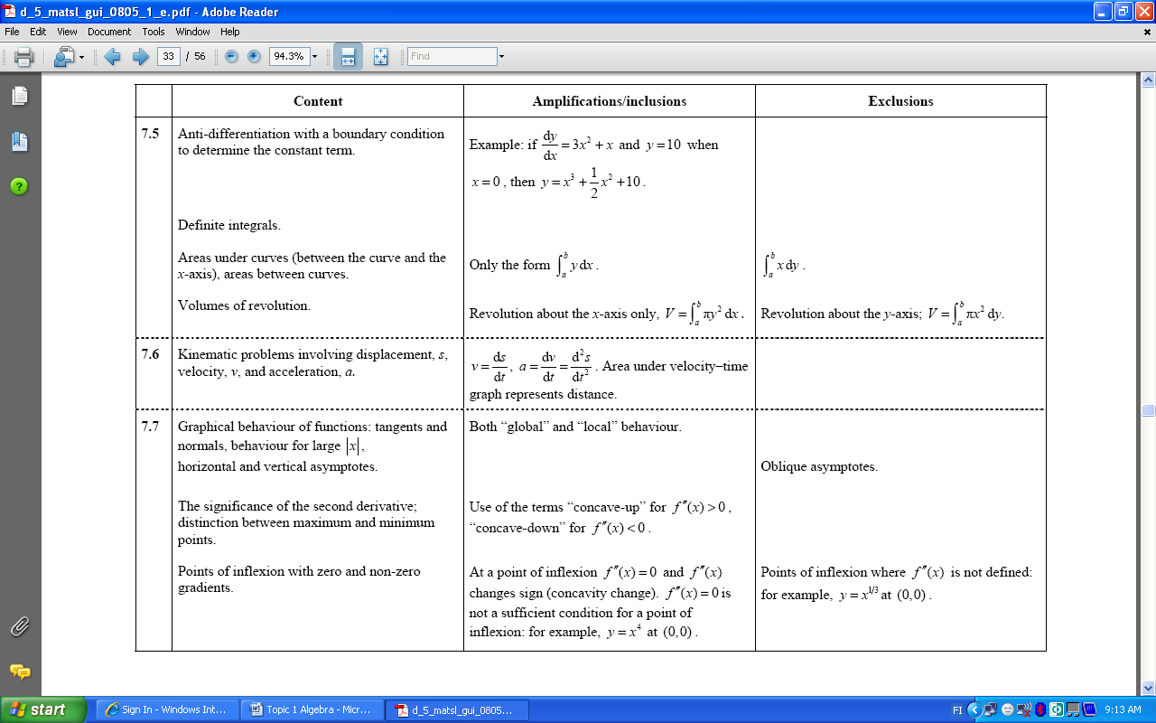

1. (NC) Find *f*(*x*) given that and *f*(0) = 10.
2. Evaluate
3. 
4. 
5. (NC) Find the area between the curve and the x-axis .
6. (NC) Find the area between the curves and .
7. (NC) Find the volume of revolution generated by revolving the region between and about the *x*-axis.

______________________

**Answers:**

1. 
2. a) 3.47 b) 1/3
3. 
4. 
5. 



1. (NC) An object moves so that its position from the origin (in meters) is given by the function, *t* in seconds. Find its
2. position
3. velocity
4. acceleration when *t* =2 sec
5. (NC) Find the distance traveled by an object moving with a velocity in the first 4 seconds.

______________________

**Answers:**

1. a) 12 m b) 24 m/s c) 30 m/s2
2. 37.3 units



1. (NC) Find the asymptotes
2. 
3. 
4. (NC) For  find the intervals where the function is
5. concave up
6. concave down
7. Find the points of inflexion of
8. 
9. 
10. 

______________________

**Answers:**

1. a) *x* = -3, *y* = 5 b) *x* = 2, *x* = -2, *y* = 0
2. a)  b) 
3. a) (0,0) b) (2,−38) c) no inflexion points