- Go to the website (www.howesmath.weebly.com)
- Copy the Body Mass Index data from excel and past into autograph to create a scatter plot.

Go to the “data” tab and enter “x,y data set” from excel.
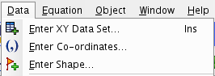

You may wish to edit the axes by pressing this button.

What type of a function might you use to “model” this data.

- Choose a random point from the data set and enter in the “skeleton” equation y=ax²+bx+c.

Repeat this with two other points. You should have a total of 3 linear equations.

- Convert this linear system into a matrix equation and use your GDC to solve for parameters a, b, and c.

- Plot your model in autograph to test if it is a good it for the data set.
Press “enter” to access the screen below and you can enter your equation. You must enter “y= (your function)”
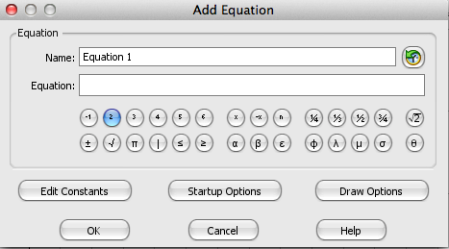
Is this model a good fit? Will it be a good predictor of BMI for a 50 year old?

- Could you use matrices to find a higher order polynomial function?

Try to find a cubic, quartic, or higher degree polynomial model.

$$y=ax^{3}+bx^{2}+cx+d$$
$$y=ax^{4}+bx^{3}+cx^{2}+dx+e$$

What degree polynomial would you need to create a system with every single data point?

- See what the computer comes up with for “best fit functions.” Hidden in the code of the autograph program, MATRIX ALGEBRA finds the best fit model!

You must select the data set so that it is highlighted, right click, and choose “best fit.”
