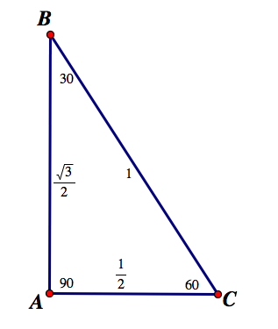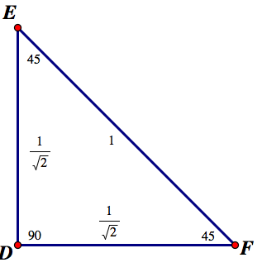

- Cut these triangles out.
- Re-write the angles, and length of each side on the back.

You can use these in conjunction with the IPAD app (or sketch the unit circle) in order to help you find EXACT values for sine, cosine, and tangent for multiples of 30, and 45 degree angles.

If you have the two triangles above memorized, you can always generate the values given below:

