**Vector Review/ Challenge**

**IB Mathematics HL**

**Mr. Howes**

**1.** The angle between the vector ***a*** = ***i*** – 2***j*** + 3***k*** and the vector ***b*** = 3***i*** –2***j*** + *m****k*** is 30°.

Find the values of *m*.

(Total 6 marks)

**2.** The diagram below shows a circle with centre O. The points A, B, C lie on the circumference of the circle and [AC] is a diameter.

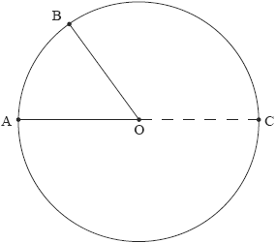

Let .

(a) Write down expressions for  in terms of the vectors ***a*** and ***b.***

(2)

(b) Hence prove that angle  is a right angle.

(3)

(Total 5 marks)

**3.** Consider the vectors . Show that if │***a***│=│***b***│ then  
 (***a*** + ***b***)**•**(***a*** – ***b***) = 0. Comment on what this tells us about the parallelogram OACB.

(Total 4 marks)

**4.** Consider the vectors ***a*** = sin(2*α*)***i*** – cos(2*α*)***j*** + ***k*** and ***b*** = cos *α* ***i*** – sin *α* ***j*** – ***k***, where 0 < *α* < 2π.

Let *θ* be the angle between the vectors ***a*** and ***b.***

(a) Express cos *θ* in terms of *α*.

(2)

(b) Find the acute angle *α* for which the two vectors are perpendicular.

(2)

(c) For *α* = , determine the vector product of ***a*** and ***b*** and comment on the geometrical significance of this result.

(4)

(Total 8 marks)

**5.** The three vectors ***a***, ***b*** and ***c*** are given by

 where *x*, *y*  .

(a) If ***a*** + 2***b*** – ***c*** = 0, find the value of *x* and of *y.*

(3)

(b) Find the exact value of │***a*** + 2***b***│.

(2)

(Total 5 marks)

**6.** (a) Consider the vectors ***a*** = 6***i*** + 3***j*** + 2***k***, ***b*** = –3***j*** + 4***k***.

(i) Find the cosine of the angle between vectors ***a*** and ***b.***

(ii) Find ***a*** × ***b***.

(6)

(b) Given two vectors ***p*** and ***q*,**

(i) show that ***p*** • ***p*** = │***p***│2;

(ii) hence, or otherwise, show that │***p*** + ***q***│2 = │***p***│2 + 2***p*** • ***q*** ***+*** │***q***│2;

(iii) deduce that │***p*** + ***q***│≤│***p***│ ***+*** │***q***│.

(8)

(Total 14 marks)

**7.** Given any two non-zero vectors ***a*** and ***b***, show that │***a*** × ***b***│2 = │***a***│2│***b***│2 – (***a*** • ***b***)2.

(Total 6 marks)

**8.** The diagram shows a cube OABCDEFG.

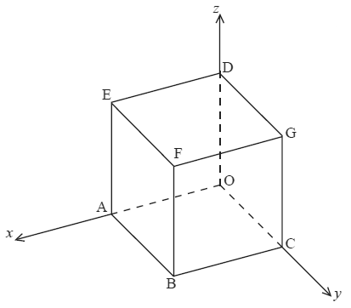

Let O be the origin, (OA) the *x*-axis, (OC) the *y*-axis and (OD) the *z*-axis.  
Let M, N and P be the midpoints of [FG], [DG] and [CG], respectively.  
The coordinates of F are (2, 2, 2).

(a) Find the position vectors  in component form.

(3)

(b) Find .

(4)

(Total 7 marks)