Warm up:
1. Consider the data set:
a.) Find the mean, median and mode. Confirm your answers using technology.

b.) Find the “five figure summary” and sketch a box and whisker plot.

2. a.) The data below is ……………………………..data.

b.) Find the mean.
c.) Determine the median.
d.) Calculate the standard deviation. Use you graphics calculator to check your work.
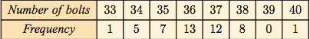

3. The data below is ……………………………………data.

a.) Find an estimate for the mean. Why can you only find an estimate for this data?
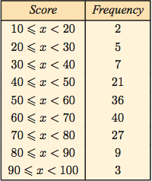
b.) Circle one: A bar graph/histogram is used to plot this data:
c.) Sketch one and determine the modal class.

d.) Describe the distribution of the data.

e.) Build a cumulative frequency column.
Using the graph paper provided and a scale of 1cm = 10 units, plot a CUMULATIVE frequency chart and estimate the IQR and median.

4.) Use the cumulative frequency graph to estimate how many students scored above 75%?

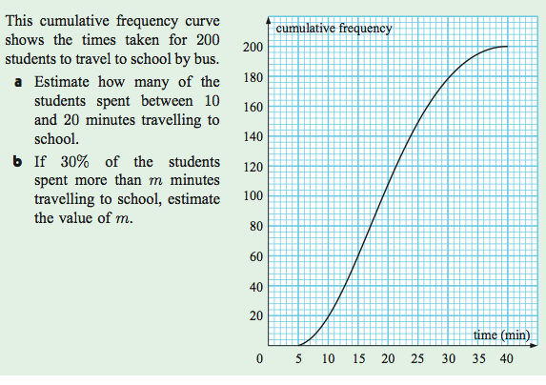

c.) How many students take over 35 minutes to get to school?

